Sant Baba Bhag Singh University
University Institute of Commerce and Management
Department of Commerce
A report on
“Financial Awareness”

Event Date: 11 April, 2022

Event Venue: Social Welfare and Development Society, VPO- Pandori kad

Theme of the Event:“ Financial Awareness”

Number of students participated in such activities:30

The Money Matters Club of University Institute of Commerce and Management, SBBSU organised an outreach camp on Financial Awareness on 11 April, 2022 at VPO, Pandori Kad in collaboration with Social Welfare and Development Society. It was conducted with an initiative to create awareness among public about the exiting trend of digital payments. The 30 students of department of Commerce and Management and 50 people of village collectively attended the outreach camp.
The Money Matters Club member Ms. Prabhjot kaur student of M.Com 4th semester and Mr. Tarun from B.com 6th Semester deliver a lecture and aware the people.
Every person learn a lot from camp that is How to apply Pan Card online? How to transfer money online? How to Book Tickets? How to pay online bill?
Students and people of village feel motivated after attending this camp.

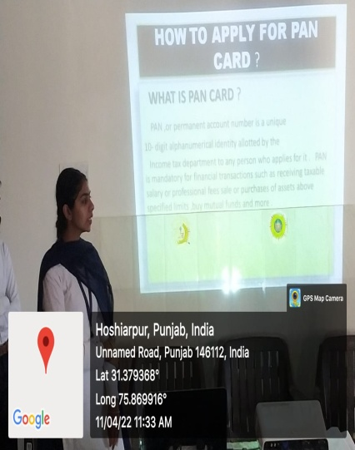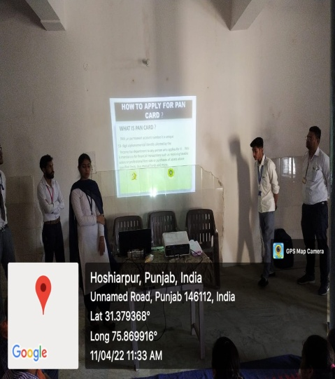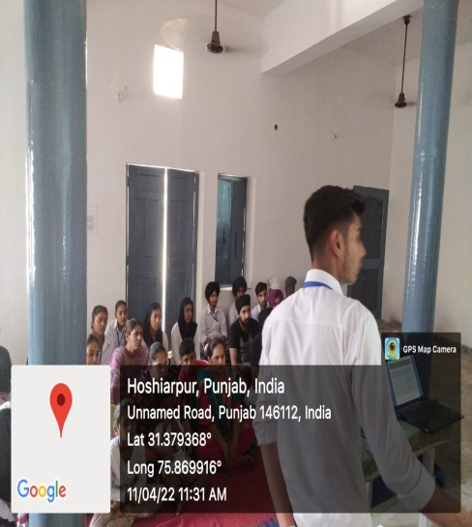

Event Coordinator: COD
Assistant Professor in Commerce Mr.LovepreetNegi

